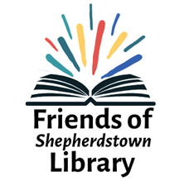

Friends of Shepherdstown Library
Gift Membership

Date ________________
Name(s) of gift recipient ___________________________________
Recipient’s address ___________________________________
Recipient’s phone ___________________________
Recipient’s email ___________________________

Name of person purchasing this gift ________________________________
Purchaser’s email ________________________________________
(This person will be sent, via email, an acknowledgement and certificate suitable for gifting.)

Circle membership level:
- FOSL Membership – Student - $10
- FOSL Membership – Supporter - $25
- FOSL Membership – Patron - $50
- FOSL Membership – Advocate - $100
- FOSL Membership – Backer - $150
- FOSL Membership – Founder $250
- FOSL Membership – Sustainer $500

Please complete and return with your check (made out to FOSL) to the library or mail to:
FOSL
145 Higbee Lane
Shepherdstown, WV 25443

